Lab -2
Basics of class,::, namespace, constructor, compilation

- Implement private and public members in a class.
Code:
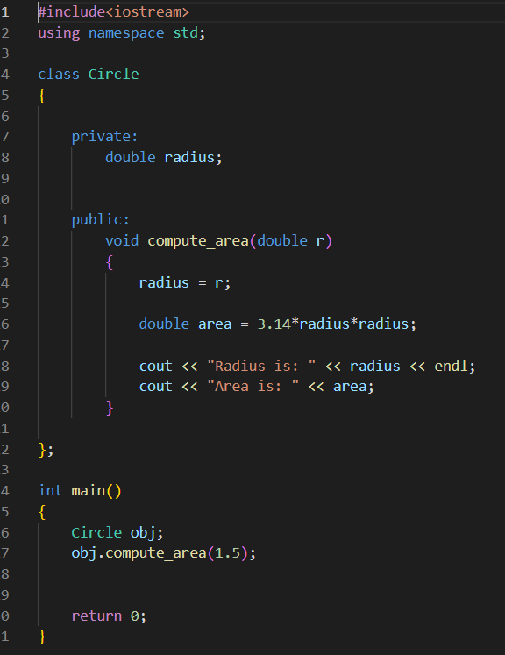
Output:
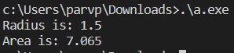

- Define a class Complex with variables real and imaginary along with following:
- void setComplex (float, float) to initialize object values.
- void displayComplex() to show the complex number
- Pass and return objects to calculate sum of two complex numbers. Display the sum.
Code:

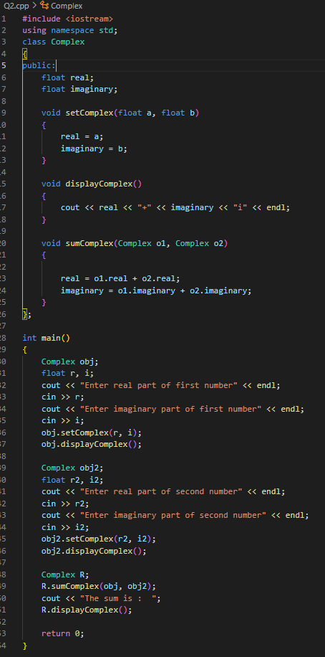
Output:
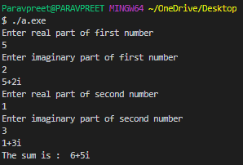

- Implement scope resolution operator : : for the following uses:
- Class functions defined outside the class
Code:
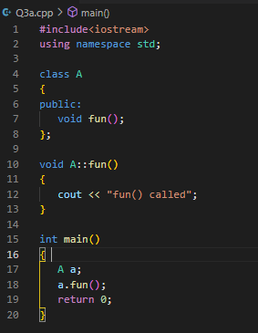
Output:
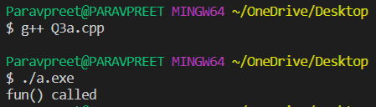
- Access a global variable with same name as a local variable
Code:
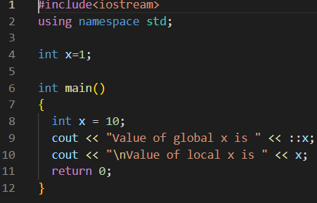
Output:
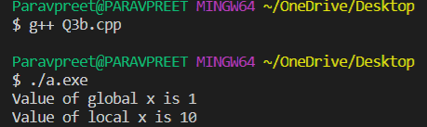
- Access a static variables
Code:
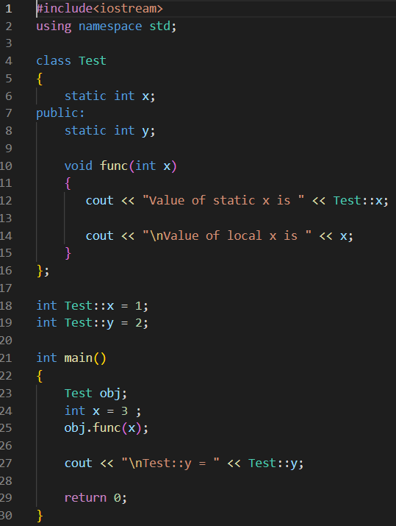
Output:
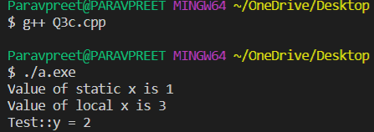
- Use inbuilt libraries (cin cout with scope resolution operator)
Code:
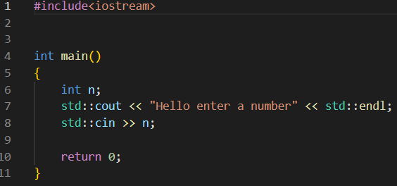
Output:
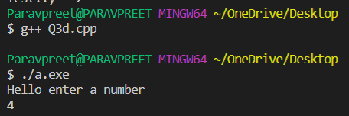

- Create a code to implement the namespace and use similar variables and functions defined in different code sections.
Code:

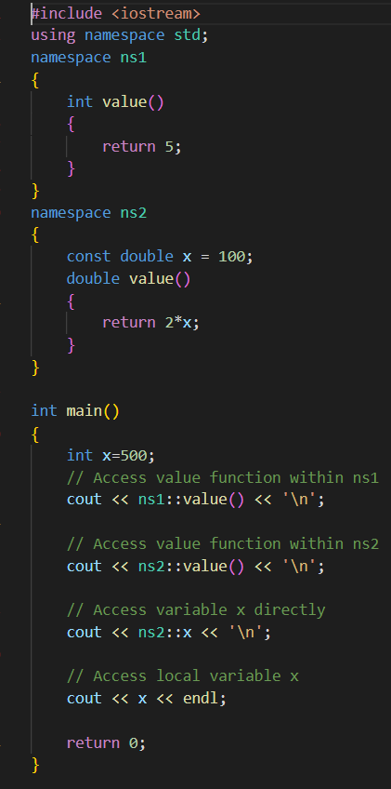
Output:
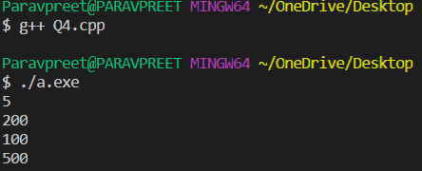
- Implement constructor and destructor in a class and a structure.

Code:
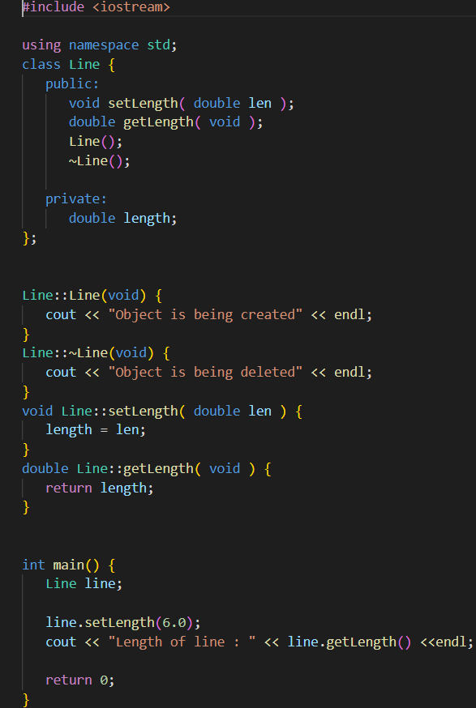

Output:
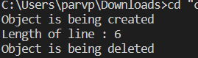

- Are you able to understand the difference between struct and class in C++. Discuss it with your instructor and fellow students.
  - Structs are value type whereas Classes are reference type.
  - Structs are stored on the stack whereas Classes are stored on the heap.
  - Value types hold their value in memory where they are declared, but reference type holds a reference to an object memory.
  - Value types destroyed immediately after the scope is lost whereas reference type only the variable destroy after the scope is lost. The object is later destroyed by the garbage collector.
  - When you copy struct into another struct, a new copy of that struct gets created modified of one struct won't affect the value of the other struct.
  - When you copy a class into another class, it only copies the reference variable.
  - Both the reference variable point to the same object on the heap. Change to one variable will affect the other reference variable.
  - Structs can not have destructors, but classes can have destructors.
  - Structs can not have explicit parameter less constructors whereas classes can. Structs don't support inheritance, but classes do. Both support inheritance from an interface.
  - Structs are sealed type.

- Discuss the following definitions with your lab instructor (a) compiler (b) interpreter (c) compile time error (d) run time error (e) syntax versus semantic bug (f) procedural oriented programming (pop) versus object oriented programming (oop)

- Compiler : A compiler is a computer program that translates computer code written in one programming language into another language..
- Interpreter : An interpreter is a computer program that directly executes instructions written in a programming or scripting language, without requiring them previously to have been compiled into a machine language program.
- Compile time error : Errors that occur when you violate the rules of writing syntax are known as Compile-Time errors.
- Run-time error : A runtime error is a program error that occurs while the program is running.
- Syntax Errors : A syntax error occurs when you write a statement that is not valid according to the grammar of the C++ language. This includes errors such as missing semicolons, using undeclared variables, mismatched parentheses or braces, etc…
Semantic Errors : A semantic error occurs when a statement is syntactically valid, but does not do what the programmer intended.
- Procedural oriented programming : A program in a procedural language is a list of instruction where each statement tells the computer to do something. It focuses on procedure (function) & algorithm is needed to perform the derived computation.
Object-oriented programming : OOP stands for Object-Oriented Programming. Procedural Compiler : A compiler is a computer program that translates computer code written in programming is about writing procedures or functions that perform operations on the data, while object-oriented programming is about creating objects that contain both data and functions

